**Dear Patient,**

Welcome to our Covid 19 newsletter, this is to keep you informed and up to date with our services throughout the Covid 19 Pandemic.

**Covid 19 update**

We have once again all had to adapt our lifestyles and go into national lockdown. This is a challenging time for all of us and we would like to reassure you that we continue to be here for you as we have the whole way through the pandemic. I appreciate things are different and we have had to change our access arrangements, but we are still here and remain open. All routine work is expected to continue.

As in the first lockdown please only come to the Surgery if you have an appointment, for anything else please use our online services or telephone the practice. Devon will now go in to Tier 2 (high) and we must continue to operate under these rules to keep everyone safe.

Please remember the NHS guidance on accessing your GP services:

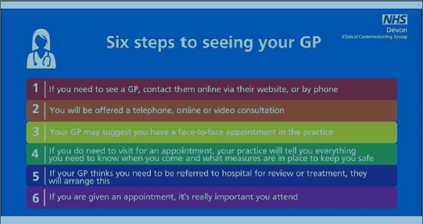

It is vital that we all follow national guidance, as a community we are seeing a higher prevalance of Covid 19 then we did in the spring and this is continuing to rise. We must all do everything we can to keep ourselves and others safe in this pandemic.

**Face Coverings:**

We fully appreciate and respect that for some, wearing a face covering is challenging whether that’s due to physical or emotional reasons, and people can apply to be exempt from wearing face coverings.

We have a duty of care to ensure both our patients and staff are kept as safe as possible and that we minimise the risk of exposure, therefore we ask patients who cannot wear a face mask to consider wearing a shield/visor when visiting the practice, for both your own protection, and that of our staff. While it doesn’t offer the same level of protection as a mask, it does help to limit exposure.

These arrangements will not affect the care you receive and you will still be seen no matter what, but we hope you appreciate that we must take every precaution in keeping our patients and staff safe.

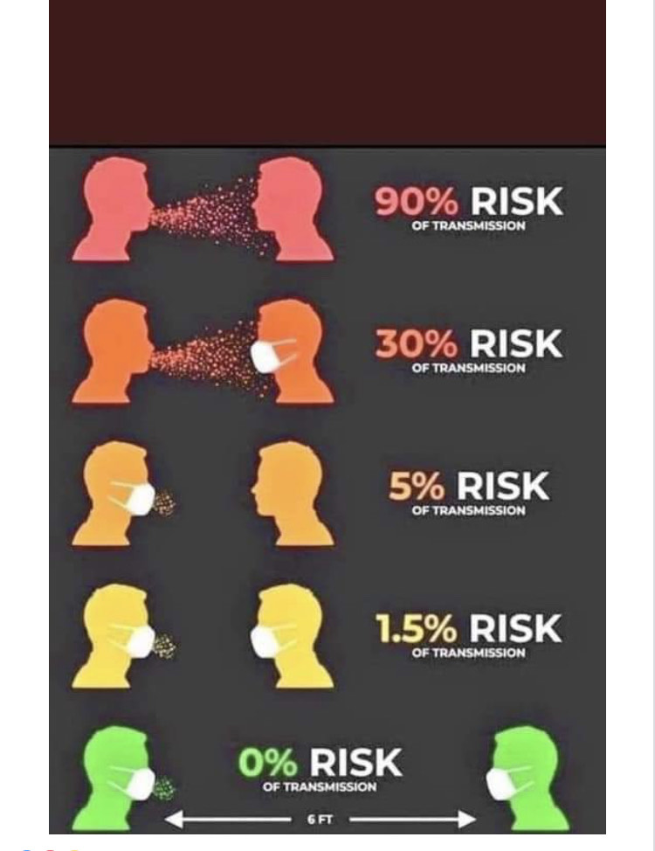

**Covid 19 Vaccination**

The Government has asked the NHS to prepare and be ready to deliver a Covid 19 Vaccination programme. Its isn’t yet certain when the vaccine will be available but our practice, along with other local practices and the Devon Clinical Comissioning Group, are working very hard to have a plan on the shelf ready to implement if and when the vaccine is ready. As you may have read or heard it is a very challenging programme due to the nature of the vaccine, the cold chain and the short shelf life. We have no further information other than what is readily available to the general public so please do not contact us regarding this. We will of course be in touch as soon as we know more.

**Flu Vaccination for the healthy 50-64 year olds.**

We have now been informed that there is a sufficient national supply of flu vaccinations for the cohort of 50-64 year olds. Please contact the surgery to book your appointment 01626 332813

**Guidance on shielding and protecting people who are clinical extremely vulnerable from Covid 19**

<https://www.gov.uk/government/publications/guidance-on-shielding-and-protecting-extremely-vulnerable-persons-from-covid-19/guidance-on-shielding-and-protecting-extremely-vulnerable-persons-from-covid-19>

**Covid 19 Research – Plasma Donors**

The NHS urgently need people who have had Coronavirus to volunteer as plasma donors. To find out more please visit <https://www.nhsbt.nhs.uk/covid-19-research/plasma-donors/>

**Covid 19 Long Recovery**

There is now a webiste containing general information on all aspects of recovering from Covid 19, including physical, emotional and psychological wellbeing. For further information please visit: <https://www.nhsbt.nhs.uk/covid-19-research/plasma-donors/>

**Home Blood Pressure Monitoring**

We are encouraging patients who require regular blood pressure monitoring to use their own blood pressure monitors. This makes sense for several reasons to protect you and to protect the NHS. The letter below explains the rationale for this in more detail and links to British heart foundation guidance on what to look for when purchasing a monitor.

Dear Patient,

You may have been asked to record some home blood pressure readings. We often get asked whether the expense of a BP monitor is really necessary.

Why do I have to record my blood pressure at home?

It is well documented that a large number of people have higher blood pressure when attending the Doctors than when they are at home, even if they don’t actually feel anxious. High blood pressure is an important condition to treat in order to reduce future risk of heart attacks and strokes but equally, if over treated (or treating for high blood pressure when actually it is normal) can lead to unnecessary side effects.

Why should I have to buy my own monitor?

You may be lucky enough to borrow one from a trusted friend but equally it may be worth your while buying one. They are readily available online and from chemists and some supermarkets from approximately £15-£25

If you have had an abnormal blood pressure recording it is likely something that will be an ongoing problem and you will need to keep an eye on it from time to time so having the ability to do this at home will be more convenient and, as discussed in the above section, lead to more accurate results. Buying a monitor is an investment in your long term health.

In previous years we were able to keep a supply of monitors at the surgery to loan out. Alternatively we would book patients multiple appointments to get readings over time with our health care assistant. The current covid pandemic raises 3 issues with this approach.

1) We are unable to loan out practice equipment for use in patient’s homes due to the risk of cross contamination from Covid 19.

2) Current pressures on appointments mean that booking an HCA appointment for a simple blood pressure check is not appropriate given that this can easily be done by patients in their own homes.

3) Risks to patients and staff can be minimised by avoiding unnecessary footfall to the surgery. Testing blood pressure at home will protect both yourself, your family and the practice staff from Covid 19.

For guidance on how to choose a monitor and how to measure it at home please see https://www.bhf.org.uk/informationsupport/heart-matters-magazine/medical/tests/blood-pressure-measuring-at-home

The Clinical team at Buckland Surgery

**Prescription Durations**

NHSE guidance is that prescriptions must remain at a 28 day duration. Please do not request to double the normal duration of your medication unless it is essential. Nationally, there are grave concerns regarding medicine wastage and stock piling which then causes shortages of drugs.